MIS OF FUND GENERATIONS’ MAAB MEMBERSHIP FOR THE PHILIPPINE RED CROSS CAVITE CHAPTER

CAPSTONE PROJECT PROPOSAL

CAVITE STATE UNIVERSITY
Cavite City Campus
Cavite City

Department of Information Technology

JOSH CRISOSTOMO JOHN BENEDICT CUSTODIO ABEGAIL JANE S. MONTEJO
ADRIEL ROBERT PANGANIBAN JOHN LOUIS D. SANORJO
January 2025

MIS OF FUND GENERATIONS’ MAAB MEMBERSHIP FOR THE PHILIPPINE RED CROSS CAVITE CHAPTER

Josh Crisostomo John Benedict Custodio Abegail Jane S. Montejo Adriel Robert Panganiban
John Louis D. Sanorjo

An undergraduate capstone project proposal presented to the faculty of the Information Technology Department, Cavite State University-Cavite City Campus, Cavite City in partial fulfillment of the requirements for the degree of Bachelor of Science in Information Technology. Prepared under the supervision of Prof. Alma De Fiesta.

INTRODUCTION

The Philippine Red Cross (PRC) is an essential organization dedicated to providing timely and critical aid in disasters, emergencies, and humanitarian crises. Focusing on disaster response, health services, and blood donations, the PRC’s mission is to alleviate human suffering and promote the well-being of vulnerable populations. The organization mobilizes resources and volunteers to assist those in need, ensuring that help reaches the most affected areas during crises (Philippine Red Cross, 2025).
In addition to disaster relief, the PRC plays an active role in various community-based services, such as medical assistance, welfare programs, and health education. The PRC strives to create resilient communities that are better equipped to handle crises and natural catastrophes by consistently broadening its scope and enhancing its offerings.
Furthermore, the Philippine Red Cross relies on programs like the Membership Accident Assistance Benefits (MAAB) Program to support its humanitarian work. The MAAB program allows individuals to contribute to the PRC’s

mission while receiving accident assistance and emergency medical services. This program enhances the PRC's ability to provide continuous support in time during disasters and other critical events, ultimately ensuring that help is always available when needed most.
The Fund Generations Department at the Philippine Red Cross Cavite Chapter manages the Membership Accident Assistance Benefits (MAAB) Program, which provides support to members, such as accident assistance and emergency medical services. However, as the program grows and the number of members increases, it becomes more difficult to manage data and benefits manually.
This study proposes the development of MIS of Fund Generations’ MAAB Membership for the Philippine Red Cross Cavite Chapter, a web-based application that will address these challenges through assisting the management of member records, and generating reports efficiently. The proposed system will enhance operational efficiency that will allow the PRC Cavite Chapter to better serve its members and manage its processes more effectively.

Statement of the Problem
The Philippine Red Cross Cavite Chapter’s Fund Generations Department faces challenges in managing the Membership Accident Assistance Benefits (MAAB) Program, ID inventory, and receiving reports from Silang and Dasma Red Cross branches manually. With increasing member numbers and complexity, these processes have become difficult to track effectively.
This study specifically seeks to address the following problems:

- Unorganized record keeping.

- ID inventory tracking issues that lead to misplaced, duplicate, or incorrect ID types being distributed due to unclear categorization.
- Limited accessibility and difficulty in updating or retrieving records promptly.

- Absence of a unified system.

Objectives of the Study
This study aims to create a web-based application that will manage the membership system of the Fund Generations under the PRC Cavite Chapter.
Specifically, the study aims to:

- design the system with the following features:

  - account creation;

  - user login and verification;

  - dashboard;

  - add members;

  - manage members;

  - generate reports;

  - id inventory;

  - manage claims;

  - claims history;
  - record of target and actual, budget and expenses and per district ;

  - audit trail;

  - notifications for nearly expiring ID and member birthday greetings.
- create the web-based application using HTML and CSS for the frontend, MySQL for database management, Canva for user interface prototypes, backend powered by Python using Flask framework
- test the web-based application; and
- evaluate the application based on the ISO 25010 evaluation instrument.

Significance of the Study
The development of this study will be essential for both the Philippine Red Cross Cavite Chapter’s Fund Generations Department and the members of the

Membership Accident Assistance Benefits (MAAB) Program. Through establishing an effective system to manage member data, and process insurance claims, the system will simplify the overall management of these operations. This will enable the PRC Cavite Chapter to offer improved service to its members and ensure the proper allocation of resources. Additionally, the system will minimize manual errors contributing to the smooth functioning of the organization. With the implementation of this system, the PRC Cavite Chapter will be better equipped to meet the needs of its expanding membership and strengthen its ability to provide prompt and accurate assistance to those in need.
This will also be significant to the researchers and future researchers as they will gain knowledge from the process of creating a system that enhances efficiency in managing membership and claims data. The study will contribute to the field of system development in non-profit organizations. Future researchers can build upon this work to develop similar systems or improve upon the techniques used, exploring new methods to improve service delivery, data accuracy, and operational transparency in such organizations.

Time and Place of the Study

The study will be conducted at Cavite State University-Cavite City Campus, situated at Pulo II, Dalahican, Cavite City, from February 2025 until the present.

Scope and Limitation of the Study

The study aims to systemize member records, track target vs. actual, and generate reports. This will allow Red Cross branches in Silang and Dasmariñas to forward their member records to the main branch in Cavite City for processing. This will ensure that the Cavite Chapter can manage and process the data effectively without redundancy or miscommunication.
The system will have two user levels: admin and staff. The admin, designated

by the PRC Cavite Chapter, will have full access to system configurations, member data, handle claims and user accounts management. Meanwhile, staff will have the same access to the system except from handling user accounts.
The system will feature key modules to organize the management of the Membership Accident Assistance Benefits (MAAB) Program, including a Dashboard for a quick and concise overview of activities, targets, and sales, ID Inventory for managing member IDs, Manage Members for member registration and tracking, and Generate Report for generating consistent and reliable reports using existing data. Additionally, the Manage Claims module will handle claims processing and claims history which held the records of processed claims. The system will also include Audit Trail to track User’s activities within the system, Settings for configuration and a Log Out feature for secure access management to ensure efficient and organized operations. The system will include a Reports Module that features a Budget vs. Expenses Tracker to compare the planned budget with actual spending, a Target vs. Actual Tracker to monitor the distribution of member IDs and compare the actual number distributed to the target, and a Per District Tracker to record and summarize data per district for better monitoring.

Conceptual Framework of the Study

The Input-Process-Output (IPO) model was adopted as a framework to evaluate the workflow of the Membership Management System for the Fund Generations under the PRC Cavite Chapter, breaking it down into three main components: input, process, and output.
In this system, the input consists of data provided by members during registration, user credentials for login and verification, membership status updates,

claims submissions, and details necessary for generating reports. This also includes the required hardware, software, and user interface prototypes. The process focuses on activities such as authenticating users, adding members, tracking membership statuses, submitting and processing claims, sending notifications, and generating reports. This involves utilizing the backend logic powered by Python and managing the data in a MySQL database. The output includes functionalities such as membership status tracking, claims history, benefits tracking, notifications, and the generation of reports.

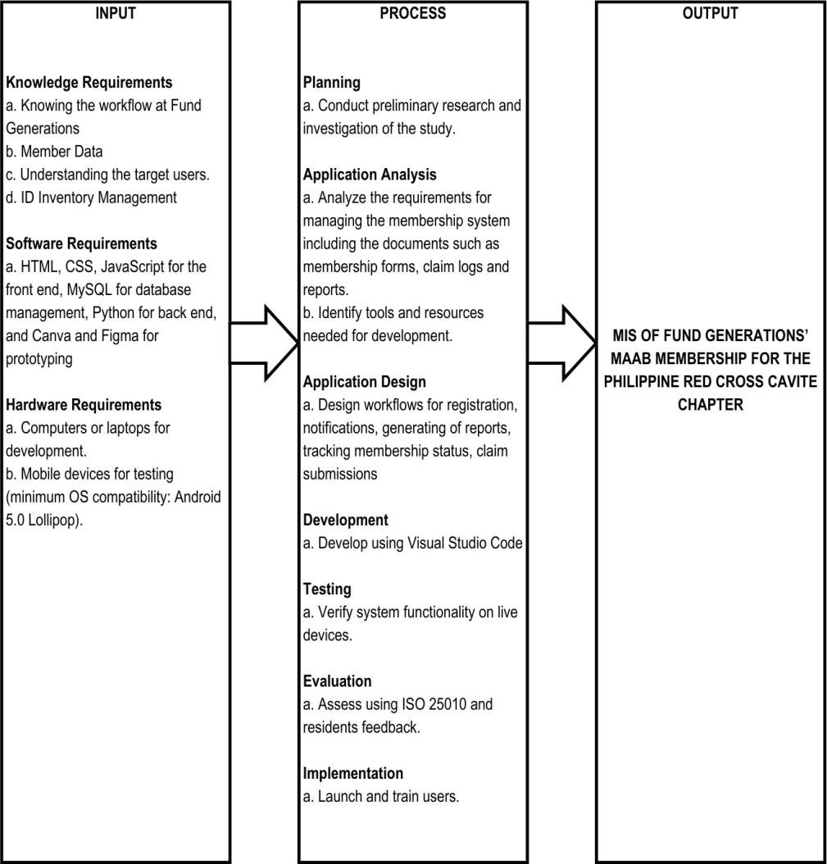

Figure 1. Conceptual framework of the study, MIS of Fund Generations’ MAAB
Membership for the Philippine Red Cross Cavite Chapter

Figure 1 illustrates the conceptual framework of the Integrated Fund Generations’ Membership System. The researchers will conduct interviews to gather user needs and expectations for the system.
To ensure reliability and effectiveness, the developers will assess the required software and hardware for development. Articles and theses will be referenced to guide the content, design, and methods used in the application.

Operational Definition of Terms

This section defines the terms used in the study and how they are applied within the context of the membership system.
Budget vs. Expenses in the system refers to comparing the planned budget of Philippine Red Cross Cavite Chapter to its current expenses. The module indicates the real time tracking for members to keep updated.
Claims refer to requests submitted by members of the Membership Accident Assistance Benefits (MAAB) Program to access benefits such as accident assistance or emergency medical services. These claims are reviewed, processed, and tracked within the membership system.
Fund Generations Department refers to the unit within the Philippine Red Cross Cavite Chapter responsible for managing the MAAB Program, including membership, claims, and benefit distributions.
ID Inventory is a system feature for managing the inventory of member IDs, including tracking issued, pending, and replacement IDs.
Manage Claims is the process of recording, evaluating, and updating the status of claims made by members. This module ensures accurate tracking of benefit distributions and provides updates to members.
Member refers to a client that purchased an insurance service from Red
Cross’ MAAB program.

Membership Accident Assistance Benefits (MAAB) Program refers to a

program offered by the Philippine Red Cross to provide accident insurance and emergency medical benefits to members. This program supports the organization’s humanitarian efforts while offering safety nets to its members
Membership System refers to the web-based application designed to manage the Philippine Red Cross Cavite Chapter's Fund Generations Department operations, including member registration, status tracking, claims processing, and report generation.
Notifications refer to updates sent to member’s email such as birthday

greetings, claims update and nearly expiring ID.

Report Generation is a functionality of the system that compiles and organizes data into comprehensive reports, including membership statistics, claims summaries, and benefit distribution records. These reports assist in decision-making and operational planning.
Target vs. Actual refers to a performance evaluation method that compares expected outcomes (targets) with actual results. It is used to determine whether goals have been achieved, exceeded, or missed. This method helps monitor the distribution of MAAB membership IDs and compare the actual number distributed with the target.

REVIEW OF RELATED LITERATURE AND STUDIES

This chapter presents a topical discussion about the other related studies that are essential and appropriate to the present topic. The following studies and literature were found on various websites, published articles, and online sources.

The Philippine Red Cross and Its Humanitarian Services
The Philippine Red Cross (PRC) is a humanitarian organization committed to providing emergency assistance, disaster relief, and various health and social welfare services. Established on April 15, 1947, through Republic Act No. 95 (Republic Act No. 95, 1947), the PRC operates as an auxiliary organization to the government while maintaining its independence. It is part of the International Red Cross and Red Crescent Movement, which upholds the principles of humanity, impartiality, neutrality, independence, voluntary service, unity, and universality.
According to the Republic Act No. 95 of 1947, the Philippine Red Cross delivers life-saving aid during disasters, medical emergencies, and community programs. However, as membership grows, manually handling records and benefits has become challenging.
Furthermore, Republic Act No. 10072 strengthens the Philippine Red Cross by ensuring transparency, accountability, and efficient resource management, which aligns directly with the objectives of the MIS of Fund Generations’ MAAB Membership of the PRC Cavite Chapter. The Act's focus on improving services, fostering partnerships, and expanding the organization’s reach is reflected in the proposed system, which will automate member data management, claims processing, and report generation. The system's development will enable the PRC Cavite Chapter to better serve its members to enhance both operational efficiency and service delivery in line with the legal framework established by the Act.

The Philippine Red Cross Membership Accident Assistance Benefits (MAAB) Program
According to the Philippine Red Cross (PRC), the Membership Accident Assistance Program (MAAB) or simply Membership Program provides a significant platform for individuals to support humanitarian work while availing accident insurance and emergency benefits. With membership fees starting at 60 pesos, the program offers accident assistance, coverage for dengue, and protection against insect and animal bites, making it a comprehensive and inclusive initiative compared to traditional insurance. The application process involves completing a membership form with personal details, which is then submitted to the local Red Cross branch. This straightforward enrollment encourages broader participation and creates opportunities for individuals to contribute to the PRC's life-saving efforts (Philippine Red Cross, 2025).
These studies help the researchers develop a system that improves membership enrollment, benefit tracking, and data organization for the Philippine Red Cross Cavite Chapter. Republic Act No. 10072 (2009) defines the membership structure and responsibilities within the organization, ensuring individuals can actively contribute to humanitarian work. The Philippine Red Cross (2025) describes how the MAAB Program provides financial assistance and medical support, making it a valuable initiative for members. Digitalizing these processes will simplify registration, enhance accessibility, and allow for better management of membership records. Management Information Systems (MIS) in Non-Profit Organizations
The growing use of web-based technology has given nonprofit organizations new opportunities to expand their reach, improve operations, and strengthen their impact on social change (Bharadwaj, M., Prakash, N., & Thomas, J. 2023). Management Information Systems (MIS) contribute to decision-making by organizing and providing structured data that aids in analysis and planning. Olajide et al. (2023) emphasize that MIS improves organizational processes by facilitating quick access to

essential information, enhancing reporting accuracy, and supporting performance evaluation. Their study indicates that a well-implemented MIS helps organizations allocate resources more effectively and make informed decisions, especially in fast- changing business environments where timely data is essential.
Hussain and Taylor (2019) studied management information systems (MIS) in non-governmental organizations (NGOs) and identified key challenges and benefits. Their research found that MIS improves data management and helps organizations make better decisions. It also increases efficiency by organizing information and tracking progress more effectively. The study emphasized that NGOs need MIS solutions according to their specific requirements. Successful implementation depends on staff training, user-friendly design, and ongoing support to ensure the system remains effective and sustainable. Several key issues are discussed, including resource availability, staff adaptability, and the significance of early stakeholder involvement to ensure the system aligns with the organization’s mission and objectives.
The research of Olajide et al. (2023) will greatly help the developers build a system that improves how the MAAB Membership of the Philippine Red Cross Cavite Chapter manages membership records and benefits. Their study explains how MIS allows faster access to data, improves accuracy, and supports better decision- making. Automating manual tasks will minimize errors and help allocate resources more effectively. With a well-designed MIS, manual errors will decrease, and processes will become more efficient. The system will also allow better resource allocation, helping the Philippine Red Cross Cavite Chapter to provide improved services to its members. Incorporating these studies will play a vital role in ensuring an organized operation and successful deployment of the PRC’s membership management system.

Web-based Systems for Membership Management

In this revolution 4.0, everything needs fast access to build a system. Of course, adequate technology is needed to achieve this goal. Web-based management information system is the right solution at this time. The rapid development and advancement in technology require one to follow developments and progress. This development has been widely used by many parties. These developments and advancements also provide great opportunities for the efficient and accurate management and utilization of information. The development of internet technology and applications provides a good condition for establishing the scientific research management information system (Noni, Ihsan, & Ahmar, 2020).
As stated by Hambali et al. (2024), membership management systems are essential for handling large numbers of members as manual record-keeping becomes inefficient and error-prone. To address this, they developed a web-based system that automates tasks, organizes data, and improves user experience. The system allows administrators to manage operations efficiently while enabling members to update profiles, access services, and join activities. A usability test with 32 participants evaluated its features, functionality, and ease of use, showing high user satisfaction and positive feedback. The study shows how digital membership systems improve management processes and provides insights for developing similar systems.
In another research conducted by Ardhianti et al. (2022), the Membership Information System (MIS) is a web-based platform designed for companies with a membership business model. It manages member transactions, automates promotions, and facilitates automatic rewards for member sales. Its features include product marketing content management, category and product data management, order and reward management, sales tracking, shopping carts, payment gateways, and shipping integration. This study demonstrates how MIS improves business operations through digital solutions that enhance transaction management and

member engagement. The shift from paper-based to digital record keeping deepens the need for automation and better data integration. While digital platforms enhance efficiency and organization, many still face challenges in interoperability, reinforcing the importance of developing more advanced membership and transaction management systems (Basir, Buckmaster, Raturi, & Zhang, 2024).
These studies will help the researchers to develop a system that manages membership records and claims for the Philippine Red Cross Cavite Chapter. Hambali et al. (2024) studied the need for digital systems as manual record-keeping becomes inefficient, demonstrating how automation improves data management and user access. Similarly, Ardhianti et al. (2022) show that web-based platforms enhance transaction tracking and member engagement through automated processes. Basir, Buckmaster, Raturi, & Zhang (2024) discuss the shift to digital records, addressing challenges in system compatibility. Their findings provide meaningful and valuable insights for creating a reliable and organized membership system.

Web designing using HTML, CSS and JavaScript
HTML serves as the foundation of the internet, providing a structured framework for organizing and displaying content. It consists of various tags that function as building blocks, allowing developers to arrange headings, paragraphs, lists, links, and multimedia in a logical order. The <html> element acts as the root, branching into the head and body sections to form a hierarchical structure. Meanwhile, CSS enhances a webpage’s visual appeal by controlling layout, colors, typography, and stylistic elements. It enables developers to create aesthetically pleasing and well-structured designs by separating content from presentation. This distinction allows for the development of visually engaging and consistently styled web pages (Mal, S., Shrivastava, V., Pandey, A., & Mishra, M., 2024). In line with these, JavaScript is a simple scripting simple language use for client-side process. It

is not use as a general-purpose language and specially designed for web development, the multiple libraries is also use towards web applications (Pathak, H. O., Shrivastava, V., Pandey, A., & Kumar, S., 2024).
The article by Semil (2022) provides a comprehensive overview of web page design using HTML, CSS, and JavaScript, highlighting the importance of each technology in modern web development. HTML serves as the foundation of web structure, CSS is responsible for the visual presentation, and JavaScript adds dynamic features and interactivity. The author emphasizes how the integration of these technologies allows developers to create websites that are not only visually appealing but also functional and responsive to users' needs. Moreover, the paper discusses the evolution of web development practices, particularly focusing on how web design has become more intuitive and accessible due to the advances in these coding languages.
The research of Semil (2022), along with the studies of Pathak et al. (2024) and Mal et al. (2024), will greatly help the developers in creating a functional and visually appealing membership system for the Philippine Red Cross Cavite Chapter. HTML will define the system’s structure, CSS will enhance its design, and JavaScript will add interactive features to improve user experience. These technologies will make the platform easy to navigate for both staff and members. Ensuring compatibility across different devices will also allow for a smooth and efficient membership management process. These studies provide useful insights into web development, which will help in building a system that meets the needs of its users.

Security and Data Privacy in Web-Based Systems
The rapid growth of web applications has increased the risk of cyber threats, making security a top priority. As stated by Gandikota et al. (2023), conducting comprehensive vulnerability assessments and penetration testing is essential in identifying and addressing security flaws that may compromise user data. As web

application vulnerabilities, particularly those outlined by Open Worldwide Application Security Project (OWASP) pose significant risks, implementing proactive security measures helps prevent breaches and protect sensitive information. Integrating security practices into the software development life cycle strengthens application integrity and enhances defense against evolving cyber threats.
The Philippines faces increasing cybersecurity threats, ranking second globally in web threat incidents in 2023. A survey revealed that ransomware attacks doubled, significantly impacting businesses and government sectors. The rise in cyber threats highlights the need for stronger cybersecurity measures, improved infrastructure, and stricter compliance with data protection regulations to safeguard sensitive information and prevent unauthorized access (International Trade Administration, 2023). Addressing the growing demand for strong cybersecurity measures, the Republic Act No. 10173 or Data Privacy Act of 2012 establishes a legal framework for safeguarding personal information in both government and private sectors. It mandates the protection of fundamental privacy rights while allowing the free flow of information necessary for innovation and economic growth. Organizations handling personal data must comply with security standards to prevent unauthorized access, disclosure, or misuse (Congress of the Philippines, 2012).
Web-based systems face increasing cybersecurity risks, making strong security measures essential. As stated by Gandikota et al. (2023), vulnerability assessments and penetration testing help prevent data breaches and strengthen system integrity. The Data Privacy Act of 2012 enforces strict data protection policies, aligning with ISO 27001:2022, which promotes a risk-based approach to cybersecurity. Ensuring data security and compliance with privacy regulations is necessary for the web-based application. Implementing security measures during development helps protect user data, reduce vulnerabilities, and maintain user trust. ISO 25010

ISO/IEC 25010 provides a framework for evaluating and ensuring software quality by defining eight key characteristics: functional suitability, reliability, performance efficiency, usability, security, compatibility, maintainability, and portability. These characteristics help assess a software product's overall effectiveness and its ability to meet user and system requirements (ISO/IEC 25010, 2023).
Functional suitability measures how well a system or product performs its intended functions. It includes sub-characteristics such as functional correctness, functional completeness, and appropriateness.
Performance efficiency evaluates the system’s performance relative to the resources it consumes under specified conditions. This characteristic includes time behavior, resource utilization, and capacity.
Compatibility refers to the ability of a product, system, or component to exchange information and perform required functions within a shared hardware or software environment. It consists of co-existence and interoperability.
Usability assesses the extent to which a system can be used effectively, efficiently, and satisfactorily by specified users in a particular context. Its sub-characteristics include appropriateness recognizability, learnability, operability, user error protection, user interface aesthetics, and accessibility.
Reliability determines a system's ability to perform its intended functions under specific conditions for a defined period. It consists of maturity, availability, fault tolerance, and recoverability.
Security focuses on protecting information and data, ensuring only authorized access while maintaining confidentiality and integrity. Its sub-characteristics include confidentiality, integrity, non-repudiation, accountability, and authenticity.
Maintainability is the ease with which a system can be modified to improve functionality, adapt to environmental changes, or correct faults. It includes modularity,

reusability, analyzability, modifiability, and testability.

Portability measures the ease with which a system, product, or component can be transferred to different environments, including hardware or software platforms. This characteristic includes adaptability, installability, and replaceability.
Developers utilize ISO/IEC 25010 as a standard evaluation framework to ensure the completeness and quality of a system in all these aspects to improve software reliability and user satisfaction.

METHODOLOGY

This chapter will outline the project design and the techniques that will be utilized by the developers to gather data for the development of the project study.

Project Design
The project design shows the context diagram of the Management Information System of Fund Generations’ MAAB Membership for the Philippine Red Cross Cavite Chapter.
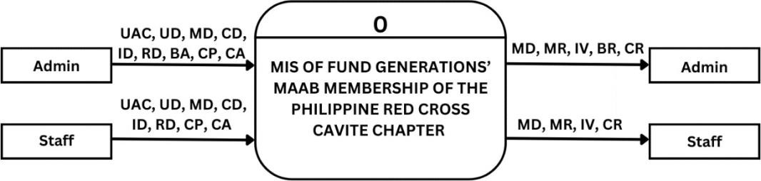

Legend:
UAC – User Account Credentials BA – Branch Access

UD – User Data CA – Create Account

MD – Member Data MD – Member Database

CL – Claims Data ID – ID Data

CP – Claims Process IV – ID Inventory

RD – Registration Data CR – Claims Report

Figure 2: Context Diagram of the MIS of Fund Generations’ MAAB Membership for
the Philippine Red Cross Cavite Chapter.

The context diagram of the Management Information System for Fund Generations' MAAB Membership of the Philippine Red Cross Cavite Chapter illustrates the flow of information between the system and its primary users: the Admin and the Staff. This system is designed to manage processes related to

membership, claims, and ID handling, ensuring smooth record-keeping and efficient processing.
In the diagram, both Admin and Staff interact with the system by providing various types of data. These include user credentials to manage system access and personal details of members for record-keeping. Additionally, they handle membership records, document claims, and oversee the different stages of claims processing. Admin and Staff also input registration data when enrolling new members, however the admin can only be the one who can create accounts to register system users.
The system processes these inputs and generates several outputs. It maintains a database to store membership records, tracks issued IDs, and produces reports summarizing processed claims. Admin users are also granted access to different branches, ensuring secure and organized handling of data.

Functional Decomposition Diagram (FDD)
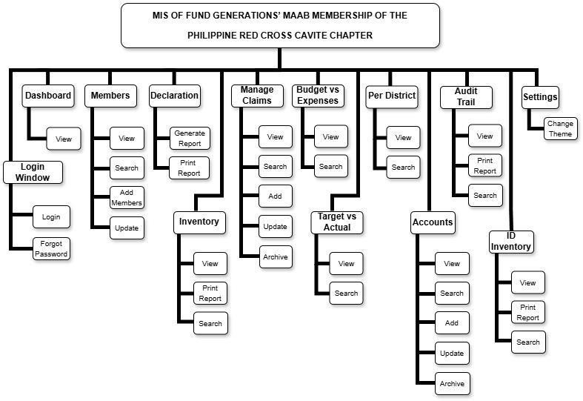

Figure 3: Functional Decomposition Diagram of the MIS of Fund Generations’ MAAB Membership for the Philippine Red Cross Cavite Chapter

Figure 3 shows the structured overview of Management Information System (MIS) for Fund Generations’ MAAB Membership of Philippine Red Cross Cavite Chapter by outlining essential functions and sub-functions. Each module are important to ensure smooth operations. Login Window requires users to enter credentials for secure access and provides password recovery options. Dashboard presents an overview of system activities and offers quick access to membership management, claims processing, reports, and other features.
Manage Members module maintains and organizes membership records. Users can view, search, add, and update details to keep information accurate. Membership Report module generates and prints reports that summarize membership status and activities. Manage Claims module handles insurance benefit processing. Users can view, search, add, update, and archive claims while keeping an organized record of transactions. Accounts module manages financial transactions related to membership fees or claims. Users can search, update, and archive records to ensure proper documentation.
Additional modules are Audit Trail that records all user activities and provides logs that users can view, print, and search for monitoring and security purposes, ID Inventory module tracks and manages membership IDs to prevent misplaced records and errors in distribution. Settings module allows users to modify system preferences such as themes to improve usability. Each module ensures accuracy, security, and efficiency in managing membership and claims.

Project Development
This shows the system's design through a flowchart that presents various levels of detail. It ranges from a broad overview to a detailed representation of specific processes within the system.
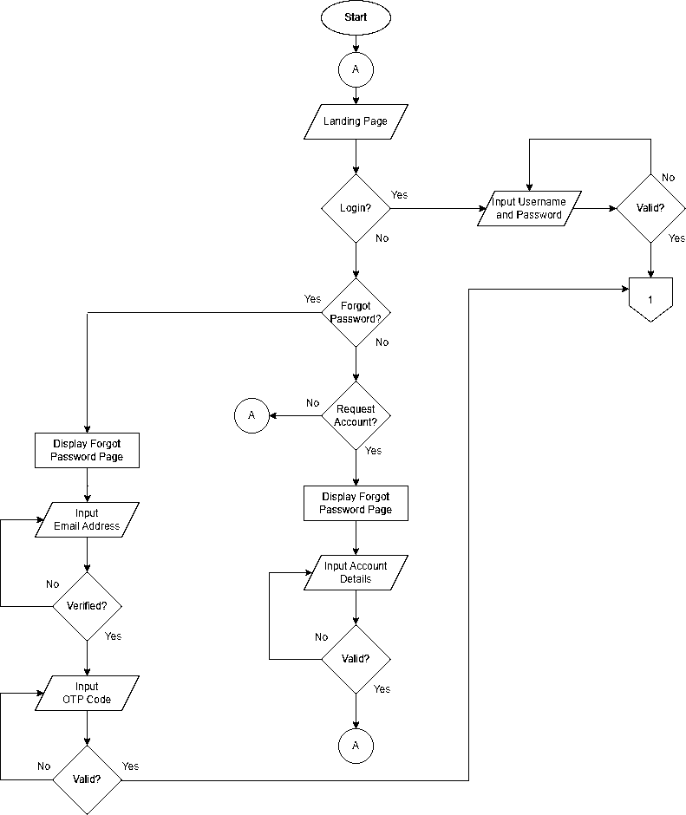
Figure 4: Context Diagram of the MIS of Fund Generations’ MAAB Membership for the Philippine Red Cross Cavite Chapter.

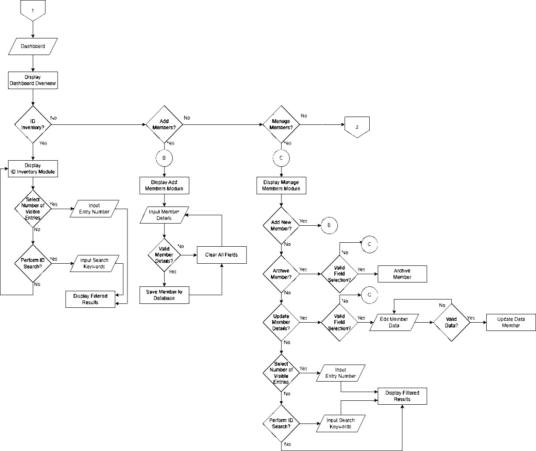

Figure 4. Continued.

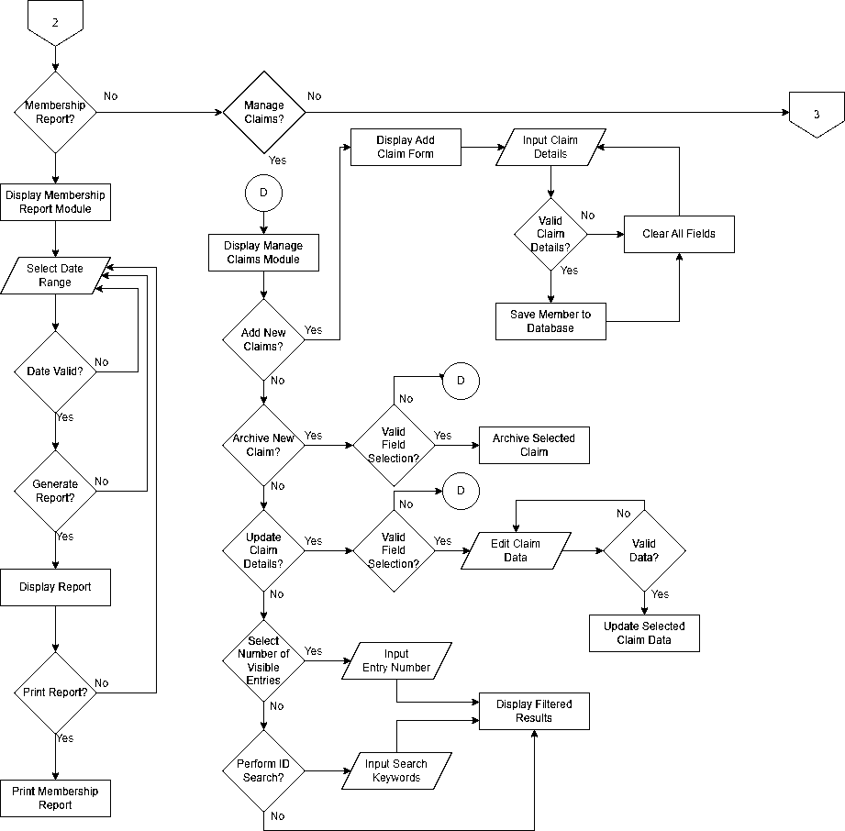

Figure 4. Continued

Operation and Testing Procedure
The operation and testing procedure will primarily aim to ensure that the project works in accordance with the specified requirements and functionality.
The following steps will be undertaken during the operation and testing:

- Open Visual Studio Code and run the application using the Flask framework.
- Open the generated localhost link provided by Flask on a web browser to access the system.
- Wait for the system to load completely.

- Test the features and components of the system by navigating through its different functionalities.
- Take note of any bugs, errors, or discrepancies encountered during the testing process.
- Debug the application using visual studio code, apply necessary adjustments in the code and re-run the system via Flask.
- Re-test the application after applying fixes to verify if the issues were resolved.
- Repeat the process of testing and debugging until the web-based application becomes stable and fully functional.

Evaluation Procedure
The system will be evaluated by adopting the ISO 25010 instrument to determine the functional suitability, reliability, performance efficiency, usability, security, compatibility, maintainability, and portability.
- Evaluation forms will be distributed to the client, the Philippine Red Cross Cavite Chapter, and 10 IT experts.
- The developers will present the system’s features and demonstrate its

operation and navigation.

- The system’s performance will be assessed by the evaluators or respondents using a Likert Scale, as shown in Table 1. Respondents will select from a scale of 1 to 5, with 5 indicating "excellent" and 1 indicating "needs improvement."
- The evaluation results will be compiled and computed to determine the mean of each criterion and the overall mean from the criteria evaluation forms.
- The system developers will apply the rating scale, shown in Table 2, to interpret the evaluation outcomes.
Table 1 presents the Likert Scale, a psychometric tool commonly used in questionnaire-based studies. It will be applied to interpret the survey results based on the evaluators' responses. A numerical rating of 5 will indicate excellent, 4 will signify very good, 3 will represent good, 2 will denote fair, and 1 will reflect poor.

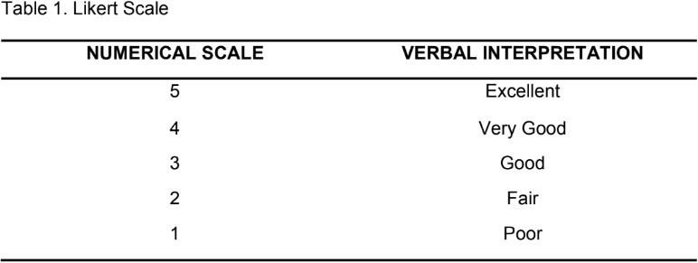

Table 2 describes the numerical rating and its equivalent in a rating scale for Descriptive Evaluation of the Mean. A numerical rating of 4.51 – 5.00 is considered excellent, 3.51 – 4.50 as very good, 2.51 – 3.50 as good, 1.51 – 2.50 as fair and 1.00 – 1.50 as poor.

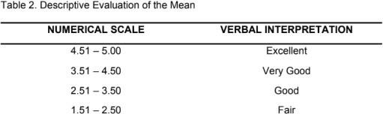

REFERENCES

Ardhianti, P. W., & Firdaus, N. (2022, August). Towards a web-based membership information system to manage product marketing content. In 2022 1st International Conference on Smart Technology, Applied Informatics, and Engineering (APICS) (pp. 127–132). IEEE. https://doi.org/10.1109/APICS56469.2022.9918774
Basir, M. S., Buckmaster, D., Raturi, A., & Zhang, Y. (2024). A review of on-farm recordkeeping systems: Moving from paper-based to digital. Precision Agriculture. Advance online publication. https://doi.org/10.1007/s11119-024- 10172-7
Bharadwaj, M., Prakash, N., & Thomas, J. (2023). Web-based technology interventions for social change: Insights from NGOs in Assam. [Journal Name], 44(4), 4165. https://doi.org/10.52783/tjjpt.v44.i4.1638
Congress of the Philippines. (2012). Republic Act No. 10173: Data Privacy Act of 2012. Official Gazette of the Republic of the Philippines. https://www.officialgazette.gov.ph/2012/08/15/republic-act-no-10173/
Gandikota, P. S. S. K., Valluri, D., Mundru, S. B., Yanala, G. K., & Sushaini, S. (2023). Web application security through comprehensive vulnerability assessment. Procedia Computer Science, 230, 168–182. https://doi.org/10.1016/j.procs.2023.12.072
Hambali, M. H., Alsamman, M., Osman, B., & Mohammed, F. (2024). Design and evaluation of a web-based membership management system. Journal of Digital System Development, 2(1), 17–29. https://doi.org/10.32890/jdsd2024.2.1.2
Hjelm, J. (2020). The implementation of an information system in a non-profit organization in a developing country: Challenges and essential factors to take

into consideration in the preliminary work and implementation process. ResearchGate. https://www.researchgate.net/publication/236953021_The_implementation_of
_an_information_system_in_a_non- profit_organization_in_a_developing_country_-
_Challenges_and_essential_factors_to_take_into_consideration_in_the_preli minary_work_and_implementatio
Hussain, A., & Taylor, W. A. (2019). Critical considerations for developing MIS for NGOs. ResearchGate.
https://www.researchgate.net/publication/261217290_Critical_Considerations

_for_Developing_MIS_for_NGOs

International Federation of Red Cross and Red Crescent Societies. (2020, January). Final ND Profile Philippines. https://www.rcrc-resilience-southeastasia.org/wp- content/uploads/2016/02/FINAL_NS-Profile_Philippines_January-22-2016.pdf International Organization for Standardization. (2022). ISO/IEC 27001:2022— Information security, cybersecurity and privacy protection—Information security management systems—Requirements. ISO.
https://www.iso.org/obp/ui/en/#iso:std:iso-iec:27001:ed-3:v1:en

International Organization for Standardization. (2023). ISO/IEC 25010:2023 Systems and software engineering—Systems and software Quality Requirements and Evaluation (SQuaRE)—Product quality model. https://www.iso.org/standard/78176.html
International Trade Administration. (2023). Philippines cybersecurity market. U.S. Department of Commerce. https://www.trade.gov/market- intelligence/philippines-cybersecurity-market
Mal, S., Shrivastava, V., Pandey, A., & Mishra, M. (2024). Web development using HTML and CSS. International Journal of Research Publication and Reviews,

5(4), 656–658. https://ijrpr.com/uploads/V5ISSUE4/IJRPR24597.pdf
Noni, N., Ihsan, N., & Ahmar, A. S. (2018). The development of research management information system based on web at Universitas Negeri Makassar. Journal of Physics: Conference Series, 1028(1), 012050. https://doi.org/10.1088/1742-6596/1028/1/012050
Olajide, F., Adekunle, A., & Afolabi, O. (2023). A review of the effectiveness of management information system in decision making. ResearchGate. https://www.researchgate.net/publication/367966053_A_Review_Of_The_Eff ectiveness_Of_Management_Information_System_In_Decision_Making
Pathak, H. O., Shrivastava, V., Pandey, A., & Kumar, S. (2024). Research on analysis of JavaScript. International Journal of Research Publication and Reviews, 5(3), 6610–6613.
https://ijrpr.com/uploads/V5ISSUE3/IJRPR24273.pdf
Philippine Red Cross. (2025). Membership. https://redcross.org.ph/membership/ Republic Act No. 95. (1947, March 22). REPUBLIC ACT NO. 95: An act to
incorporate the Philippine National Red Cross. Supreme Court E-Library. https://elibrary.judiciary.gov.ph/thebookshelf/showdocs/2/22172
Republic Act No. 10072. (2009). Philippine Red Cross Act of 2009. https://web.senate.gov.ph/republic_acts/ra%2010072.pdf
Semil, R. (2022). Web page designing using HTML, CSS, and JavaScript. International Research Journal of Modernization in Engineering Technology and Science, 4(5). https://www.irjmets.com/uploadedfiles/paper//issue_5_may_2022/23750/final/ fin_irjmets1653193454.pdf

